CITY OF MANTON
WEXFORD COUNTY, MICHIGAN
NOTICE OF OFFER FOR SALE AND INVITATION FOR SUBMISSION OF COMPETIVE BIDS
FOR CITY OWNED VEHICLE

PLEASE TAKE NOTICE that the City of Manton, whose offices are located at 306 W. Main St., Manton, Michigan, 49663, is offering for sale a City-owned 2015 Club Car Precedent golf cart as depicted in the photo below:

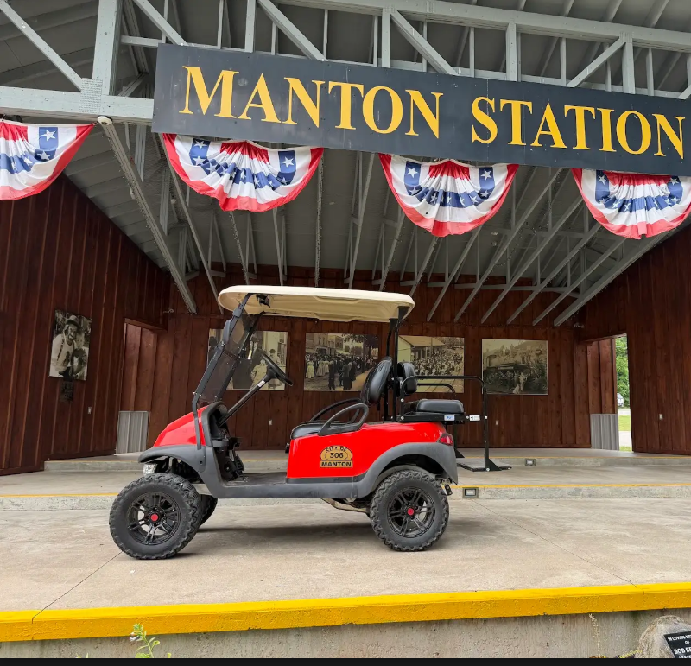
Members of the public are invited to submit bids in sealed envelopes identifying the purchase price offered for the golf cart and the name, address and phone number of the person making the bid, by delivering the bid to the City offices located at 306 W. Main St., Manton, Michigan, 49663, by 3 p.m. Friday, August 21, 2026. Any bid over the amount of $5,400 will be considered. The golf cart may be inspected between the hours of 9 a.m. and 4 p.m., Monday-Friday, by contacting the City Clerk at (231) 824-3572 or by coming to the City offices during those same hours.
The bids shall be opened and read aloud by the City Clerk at the City Commission meeting at 7 p.m. on Tuesday, August 25, 2026, at the located at Manton Senior Citizen Center, 302 West Main Street, Manton, Michigan, 49663. Thereafter, the City Clerk shall report the bids to the City Commission at this same meeting on August 25, 2026. The City Commission may accept or reject any and all bids if deemed advisable.

